Name :Sk.Kashifa

Registration no :192121135

Conference Management system

Class diagram :

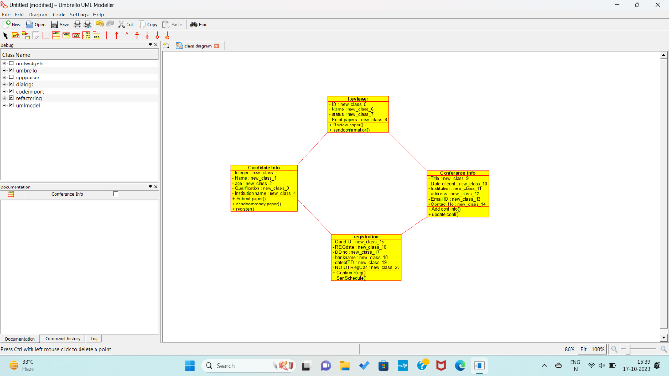

Sequence diagram:

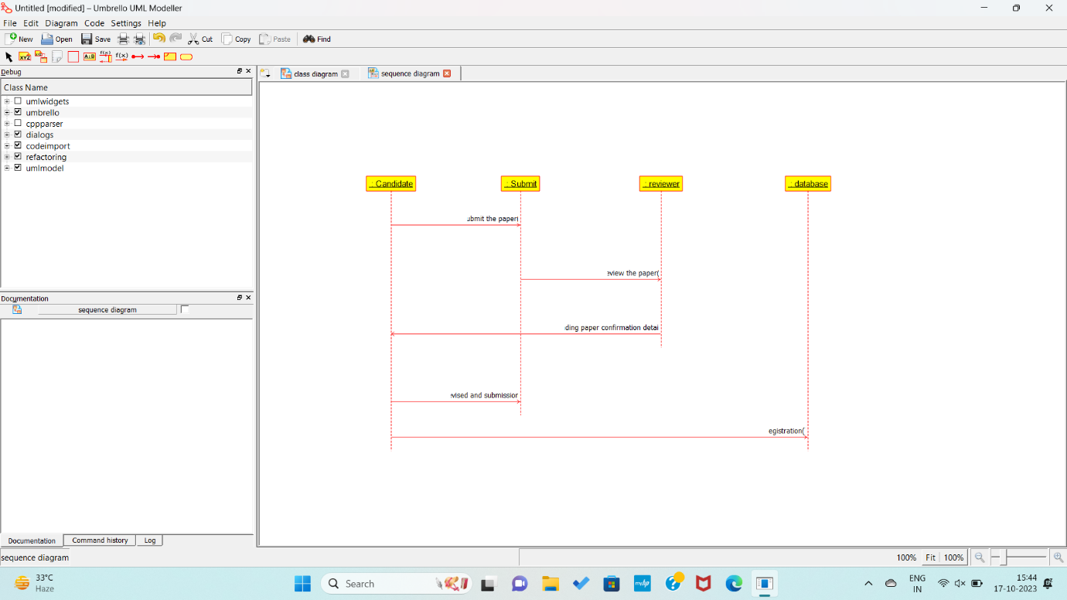

Component diagram :

